**Digital Technologies – DTE2U**

**Evidence template – Develop a digital outcome AS91893 and AS91897**

**Part 1: Decompose your digital outcome**

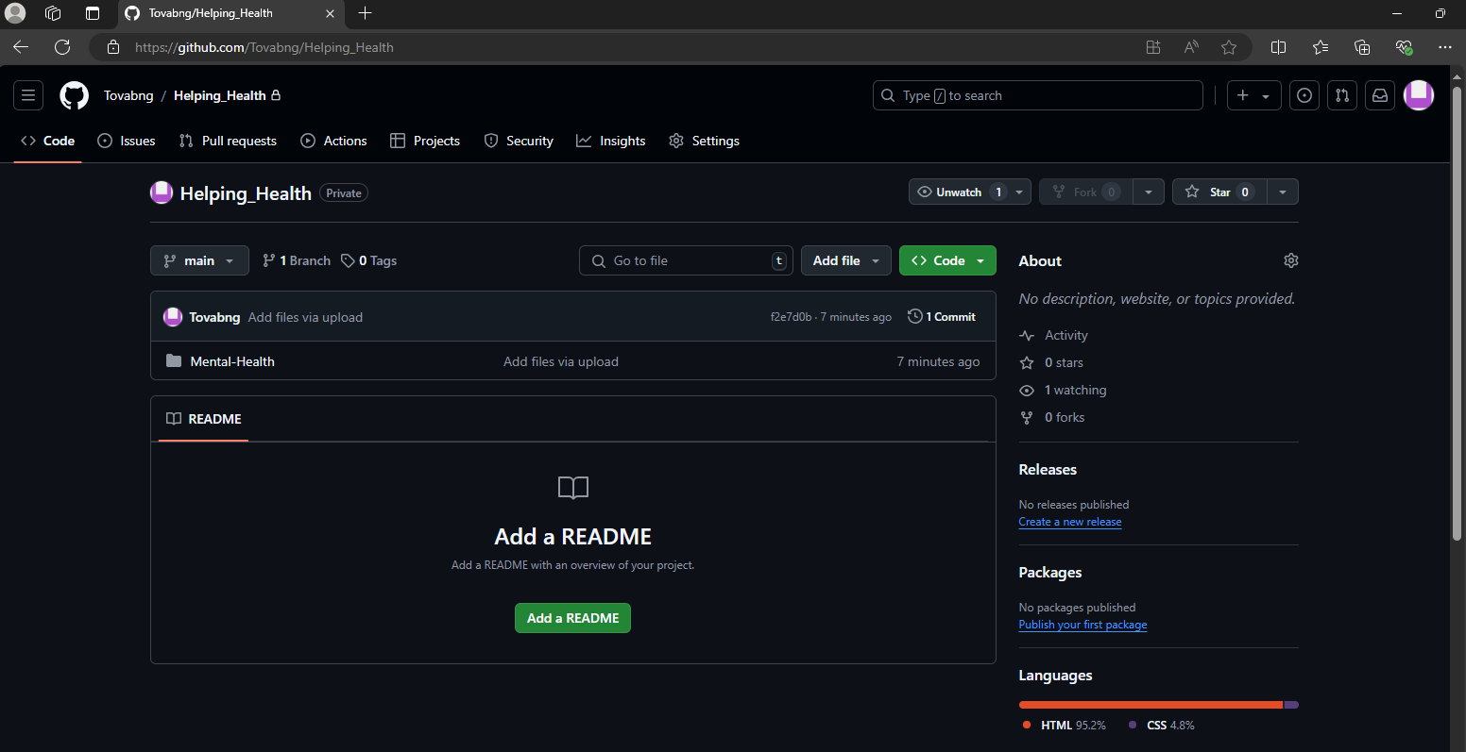

This image above is evidence of an unsuccessful upload to github …

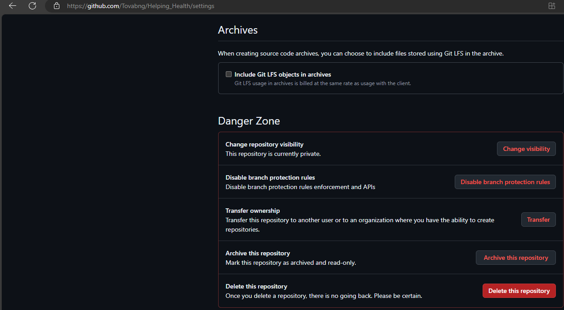

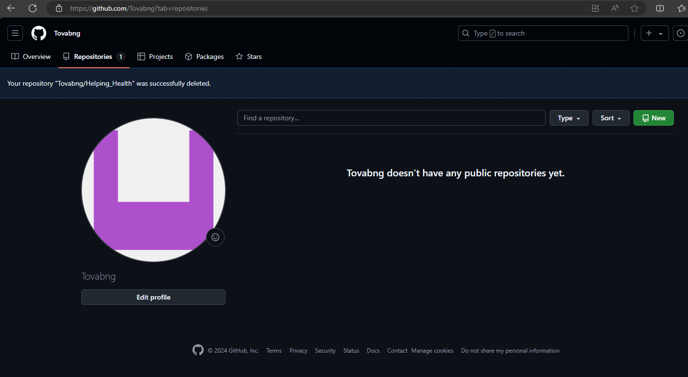

This image above shows that I didn’t select public when I created my first repository.

**Part 2: Project Management.**

**Part 3: Develop/Trial components.**

**Part 4: Develop/Test Outcome**

**Part 5: Relevant implications**

**Part 6: Evaluate**

**Part 7: Present your Outcome**

**Part 8: Reporting.**